IFRS 9 CREDIT RISK MODELLING
Week 5: PD Modelling Framework and Macroeconomic Variables
Learning Notes for Banking Professionals

Objective: Understand how Probability of Default (PD) models work with macroeconomic variables in IFRS 9 Expected Credit Loss calculation.

1. Introduction to IFRS 9 PD Modelling
The core idea is that credit risk should not be viewed only through past averages. A bank in CIB must keep an eye on the current cycle, expected future conditions, and the time value of money when measuring risk, pricing exposure, and interpreting outcomes.
Expected Credit Loss (ECL) = Probability of Default (PD) × Loss Given Default (LGD) × Exposure at Default (EAD)
This formula forms the foundation of IFRS 9 compliance. To calculate ECL accurately, we need to estimate PD correctly. But here's the key question: Should PD be based on historical data or future expectations?
IFRS 9 requires a Point-In-Time (PIT) approach, which means we must forecast future default probabilities based on current economic conditions and expected changes.

1.1 Understanding Through-The-Cycle (TTC) vs Point-In-Time (PIT)
Through-The-Cycle (TTC) PD:
- Based on long-term historical average default rates
- Smooths out economic cycles—both good and bad years
- Used by rating agencies like Moody's and Fitch
- Example: A company has defaulted 2 times in the last 20 years. TTC PD = 2/20 = 10%
Point-In-Time (PIT) PD:
- Reflects current economic conditions and forward-looking expectations
- Increases during economic downturns, decreases during booms
- Required by IFRS 9 for ECL calculation
- Example: Same company with 10% TTC PD might have 6% PIT PD in good times or 15% PIT PD in recession
Think of it like weather forecasting: TTC is 'historical average temperature in January,' while PIT is 'tomorrow's specific weather prediction based on current conditions.'
A point-in-time (PIT) view reacts quickly to the present economic environment. When conditions weaken, the risk view becomes more cautious; when conditions improve, the view may soften faster.
A smoother long-term view behaves more like an average line. It does not jump sharply with every monthly or quarterly change. In banking, this is useful when a model must avoid overreacting to temporary noise.
Simple analogy: a thermometer measures today's temperature, while a seasonal average tells whether the climate is generally warm or cold. Both are useful, but they answer different questions.
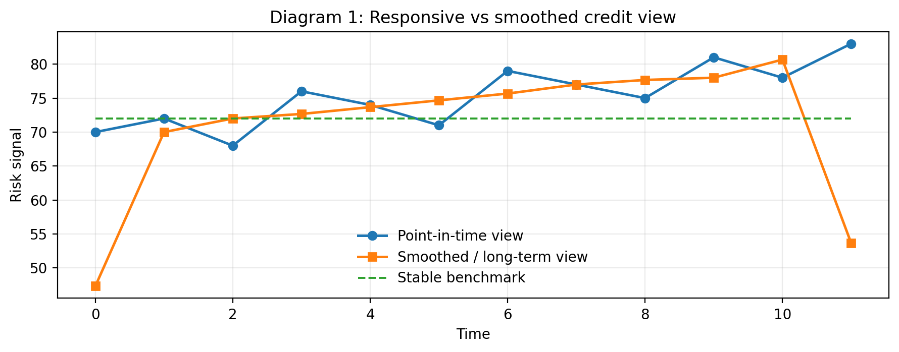

In CIB banking, PIT thinking is especially helpful for large corporate portfolios because the macro environment can change repayment capacity quickly. A bank therefore watches the current cycle, not only the historical average of the borrower or sector.

1.2 Why IFRS 9 Moved from TTC to PIT
Before IFRS 9, banks used TTC PD for provisioning. This created a significant problem:
- During economic booms: Default rates are low, TTC PD stays flat, banks report high profits
- During recessions: Defaults spike, but banks had already provisioned during good times, limiting credit damage
- Result: No adequate reserves when they were actually needed
IFRS 9's PIT requirement ensures that provisions increase when economic indicators deteriorate, giving banks more realistic loss estimates.
IFRS 9 requires attention to expected future conditions, not just history. That means economic signals such as growth, price levels, and interest-rate movements are relevant because they can change the borrower’s future ability to pay.
The practical message is simple: yesterday’s data is a starting point, not the full answer. A credit model should be able to move when the economy moves.
Simple analogy: planning a road trip only from last year’s weather is weak planning. Current weather plus the forecast gives a safer decision.

2. Next 12 Months (N12M) Probability of Default
What is N12M PD?
N12M PD is the probability that a borrower will default within the next 12 months from today. It's the most forward-looking measure a bank can use.
Key Characteristics:
- Time Horizon: Exactly 12 months from measurement date
- Basis: Current economic conditions + expected near-term changes
- Recalculation: Updated every quarter as conditions change
- Stage 1 Application: Banks use N12M PD for Stage 1 loans (performing loans without significant increase in credit risk)
Practical Example: If a bank is assessing a small business loan today (January 2024), the N12M PD represents the chance that business will default before January 2025.

3. Macroeconomic Variables in PD Models
Default doesn't happen in isolation. When an economy falters, defaults increase. When it thrives, defaults decrease. This relationship is captured through macroeconomic variables.

3.1 The Core Macroeconomic Variables
A. Gross Domestic Product (GDP)
Definition: Total value of all goods and services produced in an economy during a specific period
Relationship with PD:
- ↑ GDP Growth: Economy is expanding → Companies earn more → Defaults decrease → PD ↓
- ↓ GDP Growth: Economy contracts → Companies struggle → Defaults increase → PD ↑
Why GDP Growth Rate, Not Absolute GDP?
- What matters is whether the economy is improving or declining
- A 3% growth rate is good if previous rate was 2%, but concerning if previous was 5%
- Therefore, models typically use GDP Growth Rate (%) or Year-over-Year GDP change
Example: In 2020 (COVID crisis), India's GDP contracted by -6.6%. Defaults surged. In 2021, growth returned to +8.7%, and defaults normalized.
B. Unemployment Rate
Definition: Percentage of the labor force that is unemployed and actively seeking work
Relationship with PD:
- ↑ Unemployment Rate: More jobless → Less income → Defaults increase → PD ↑
- ↓ Unemployment Rate: More employed → Stable income → Defaults decrease → PD ↓
Example: When unemployment rises from 4% to 7%, consumer loan defaults typically increase because people have less income to repay debt.
C. Interest Rates
Definition: The cost of borrowing money, typically measured by central bank policy rate
Relationship with PD (Complex):
- ↑ Interest Rates: Higher borrowing costs → Higher EMIs for existing borrowers → Stress increases → Defaults rise → PD ↑
- ↓ Interest Rates: Lower borrowing costs → Relief for borrowers → Defaults decrease → PD ↓
- However: Interest rate increases sometimes signal economic overheating (inflation control), which can also hurt borrowers
Example: When RBI raised repo rate from 4% to 6.5% in 2022-23, many floating-rate borrowers faced higher EMIs, increasing defaults.
D. House Prices / Real Estate Index
Definition: Average price of residential properties in the market
Relationship with PD:
- ↑ House Prices: Collateral value increases → LTV decreases → Loss Given Default decreases → More loan cushion
- ↓ House Prices: Collateral value decreases → LTV increases → Loss severity increases → More risk
- Also indicates household wealth and confidence: Rising prices signal economic optimism
Example: During 2008 financial crisis, house prices crashed. Borrowers with mortgages owed more than their homes were worth ('underwater'), increasing defaults.

Time value of money, nominal rate, and effective interest rate
The time value of money means that one rupee today is not the same as one rupee later. That is why discounting exists.
A nominal interest rate is the quoted rate. An effective rate reflects the real growth of money after compounding. When compounding happens more than once a year, the effective rate becomes higher than the quoted nominal rate.
Common formula:
Effective annual rate = (1 + nominal rate / number of compounding periods) ^ number of compounding periods − 1
Discounting factor logic also appears here. A discount factor converts a future amount back to today’s value. In plain language, it answers: ‘How much is that future rupee worth right now?’
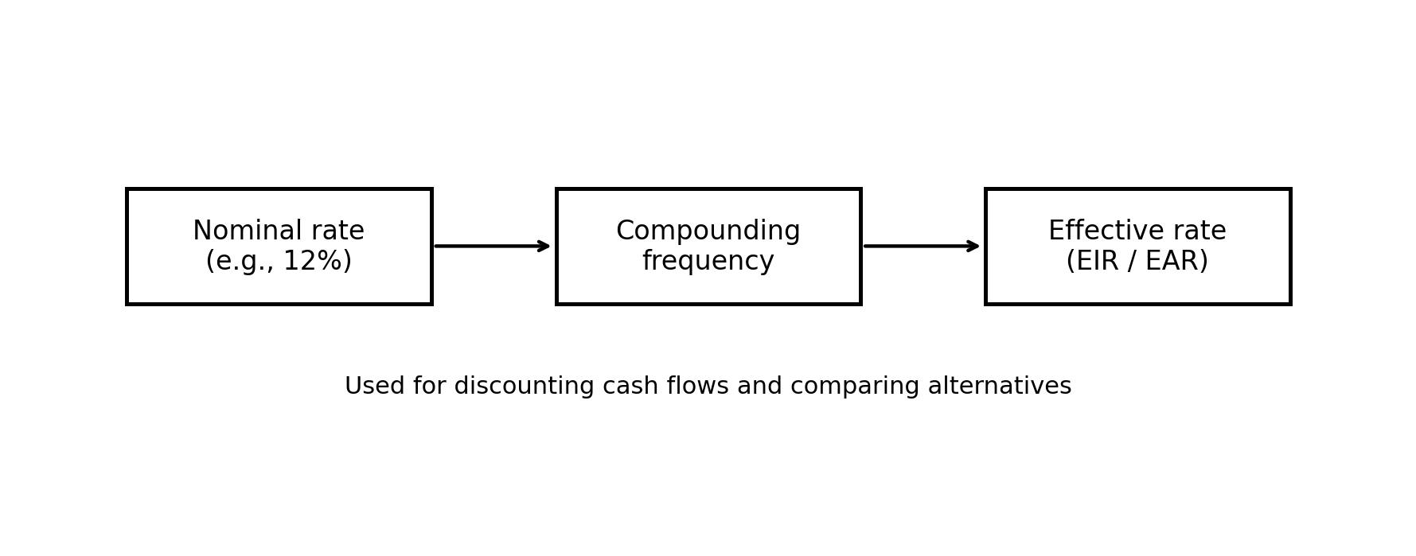
Diagram 2: From quoted rate to effective rate and then to discounting

Illustrative example: nominal rate versus effective rate
Quoted nominal rate | Compounding | Effective annual rate | Interpretation
12.00% | Monthly | 12.68% | Same label, but slightly higher actual growth because interest compounds through the year.

This is important in credit work because cash-flow valuation, pricing, and present-value calculations depend on the effective rate, not only the label on the contract.
GDP versus real GDP
Nominal GDP measures output at current prices. Real GDP removes the effect of price changes, so it better reflects actual volume of production.
This difference matters because a rise in nominal GDP can come from inflation rather than genuine growth. For credit risk, the real activity trend is usually more informative than a price-driven number.
Simple analogy: if the price of a basket doubles but the number of items stays the same, the bill rises, yet the actual basket has not become bigger.
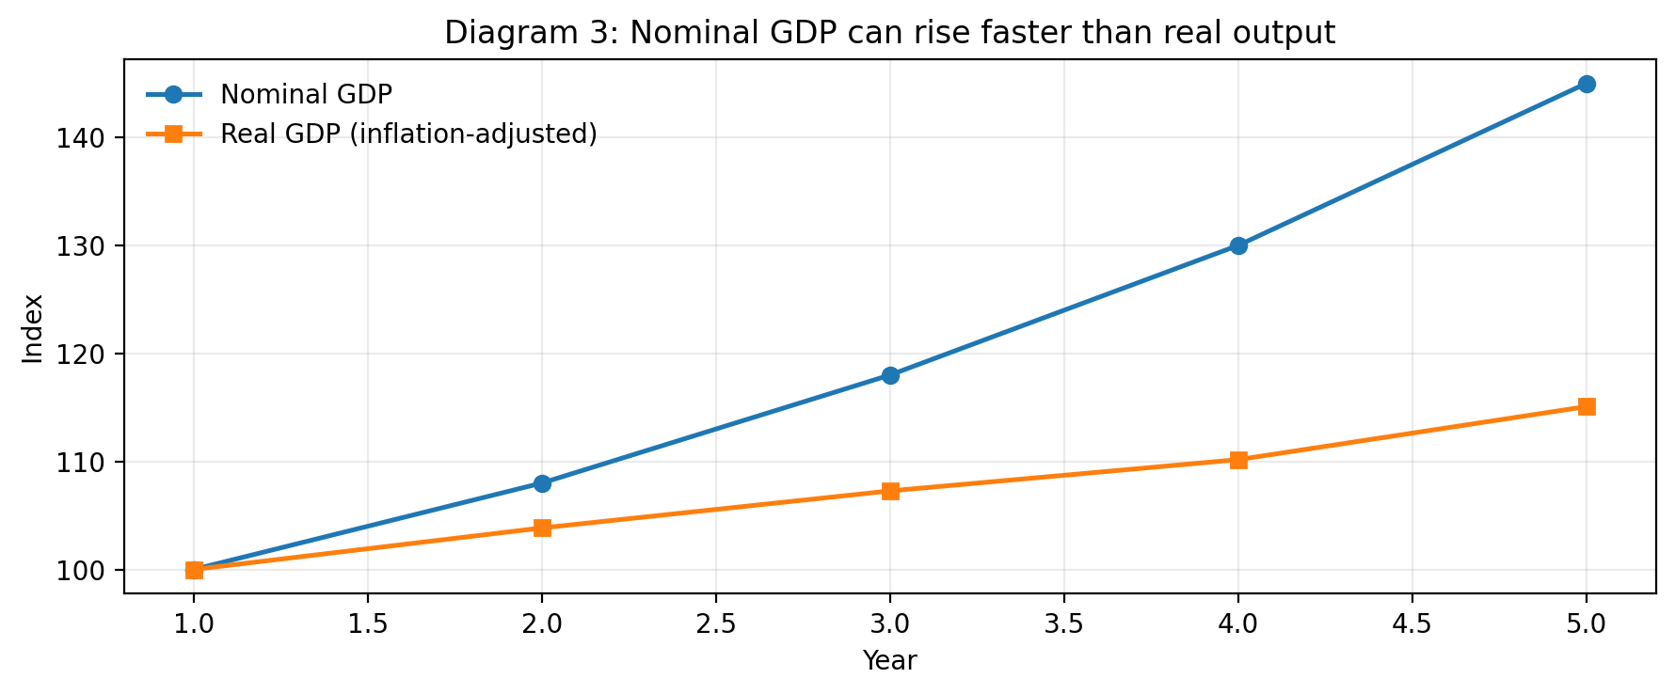
Diagram 3: Nominal GDP may rise even when real output is weaker

Illustrative example: nominal GDP and real GDP
Year | Nominal GDP | Price index | Real GDP
Base year | 100 | 100 | 100
Later year | 132 | 132 | 100

The example shows that nominal GDP can increase while real GDP remains unchanged after inflation is removed.

4. Transformation of Macroeconomic Variables
Raw macroeconomic data can't be directly plugged into PD models. They need to be transformed to make them statistically useful.

4.1 Why Transform Variables?
- Some variables have trends (GDP always grows long-term) that mask relationships
- Some are cyclical (unemployment goes up and down) - need to isolate the cycle
- Statistical models work better with standardized, normalized data
- Make the relationship with defaults clearer and more predictable

4.2 Common Transformations
A. Year-over-Year (YoY) Growth Rate
Calculation: (Current Year Value - Previous Year Value) / Previous Year Value × 100%
- Removes long-term trends
- Captures acceleration or deceleration
- Example: If GDP is ₹250 lakh crore in 2023 and ₹270 lakh crore in 2024, YoY growth = (270-250)/250 × 100% = 8%
B. Deviation from Trend / Cycle Component
Calculation: Actual Value - Trend Value
- Isolates the cyclical component (the boom and bust part)
- Removes structural long-term patterns
- Example: GDP trend might be 7% growth, but actual is 5%. Cycle = 5% - 7% = -2% (contraction)
C. Standardization (Z-score)
Calculation: (Value - Mean) / Standard Deviation
- Centers data around 0 with standard deviation of 1
- Makes variables comparable across different scales
- Example: Unemployment rate (%) and GDP growth (%) measured on different scales become comparable
D. Lagging / Leading Indicators
Lagged Variables: Use data from previous quarters (GDP from Q1 to predict defaults in Q2)
- Reflects time-lag between economic change and actual defaults
- A job loss today leads to default in 2-3 months, not immediately
- Default Rate in Q2 = f(GDP Growth in Q4, Unemployment in Q4, Interest Rate in Q1)

5. Building PD Models with Macroeconomic Variables

5.1 Basic Model Structure
Two-Step Approach:
- Step 1: Develop TTC PD from historical data (base default rate)
- Step 2: Adjust TTC PD using macro variables to create PIT PD (forward-looking)
Simplified Formula:
PIT PD = TTC PD × Macro Adjustment Factor | Example
PIT PD = 5% × 1.2 | = 6% (in stress scenario)
PIT PD = 5% × 0.8 | = 4% (in benign scenario)

5.2 Illustration: From TTC to PIT
Let's say a bank has determined a segment's historical TTC PD = 3% based on 10 years of data.
Scenario Analysis:
Scenario | GDP Growth | Unemployment | Adjustment Factor | PIT PD
Benign | +5% | 3.5% | 0.70 | 2.1%
Base Case | +3% | 5.0% | 1.00 | 3.0%
Stress Case | -2% | 8.5% | 1.80 | 5.4%

This shows how the same segment has different PDs depending on macroeconomic conditions. In stress (recession), PD nearly doubles; in benign (boom), it decreases by 30%.

5.3 Common Model Types
1. Logistic Regression Models (Most Common)
- Uses: PD = 1 / (1 + e^(-X))
- X = combination of borrower characteristics + macro variables
- Output: Probability between 0% and 100%
2. Vasicek Model
- Uses: Asset value framework (borrower's assets vs liabilities)
- Incorporates: Systemic risk (overall economy) + idiosyncratic risk (company-specific)
- Popular in: Advanced internal rating-based (IRB) approaches
3. Machine Learning Models
- Uses: Random Forests, Gradient Boosting, Neural Networks
- Advantage: Can capture complex non-linear relationships
- Challenge: Less interpretable ('black box') - harder to explain to regulators

6. Practical PD Modelling Framework

6.1 Step-by-Step Process
Step 1: Data Collection & Preparation
- Gather 5-10 years of historical loan data (defaults, prepayments, current balances)
- Collect macroeconomic data from central bank, statistics bureau
- Clean data: Remove outliers, handle missing values, standardize formats
Step 2: Define Default & Staging
- Default Definition: Usually 90+ days past due or bankruptcy
- Observation Period: Track borrowers for 12 months (for N12M PD)
- Classification: Non-Default = 0, Default = 1 (binary outcome)
Step 3: Segment the Portfolio
- Build separate models for: Retail, SME, Corporate, Consumer loans
- Each segment has different PD drivers and sensitivities to macro variables
- Example: SME PD sensitive to industrial production; retail housing PD sensitive to house prices
Step 4: Select Macro Variables
- Run correlation analysis: Which macro variables correlate with defaults?
- Test causality: GDP growth may cause, not just correlate with, lower defaults
- Test lag: Determine optimal time lag (does 1-quarter lag work best, or 2-quarter?)
- Avoid multicollinearity: GDP and Industrial Production both measure same thing
Step 5: Model Development & Validation
- Split data: 70% training, 30% testing
- Fit logistic regression / chosen model on training data
- Test on holdout data: Check predictive power (AUC, Gini coefficient, KS statistic)
- Regulatory backtesting: Compare predicted vs actual defaults over time
Step 6: PIT Adjustment
- Separate model TTC component from macro adjustment
- Calibrate using recent economic scenarios (base case, stress, benign)
- Apply to TTC to produce forward-looking PIT PD
Step 7: Ongoing Monitoring
- Monitor model performance quarterly
- Update macro inputs as new data arrives
- Recalibrate annually or when significant economic shifts occur

7. Real-World Banking Example
Case Study: Small Business Lending Portfolio
A mid-sized Indian bank wants to build an N12M PD model for small business loans (₹10-50 lakh). Let's walk through their approach:
Background Data:
- 10 years of historical data: 5,000 loan accounts
- Total defaults observed: 150 loans (3% historical default rate = TTC PD baseline)
- Macro data: GDP growth, Industrial Production, Lending Rate, Unemployment (quarterly)
Key Findings:
Macro Variable | Correlation with Default | Relationship
GDP Growth (lagged 1 quarter) | -0.45 | Negative: Lower growth → Higher defaults
Industrial Production | -0.52 | Negative: Factory slowdown → Business stress
Lending Rate | +0.38 | Positive: Higher rates → Payment stress
Unemployment Rate | +0.41 | Positive: Job losses → Business defaults

Model Output (Logistic Regression):
PD = Base TTC (3%) × Macro Adjustment
Macro Adjustment = e^(β₁×GDP + β₂×IP + β₃×LendingRate + β₄×Unemployment + Constant)
Scenario Results (as of Q3 2024):
Scenario | GDP Growth | Industrial Prod. | Adj. Factor | PIT PD | Interpretation
Severe Recession | -5% | -8% | 2.50 | 7.5% | Portfolio doubles in stress
Mild Recession | 0% | -2% | 1.60 | 4.8% | Significant elevation
Base Case | 6% | 3% | 1.00 | 3.0% | Current stable state
Strong Growth | 8% | 6% | 0.70 | 2.1% | Benign conditions

Interpretation: The bank's small business portfolio is quite sensitive to macroeconomic cycles. In a severe recession, PD could spike to 7.5%, requiring higher provisions. In strong growth, it could fall to 2.1%.

8. Key Takeaways for Banking Professionals
- IFRS 9 requires Point-In-Time (PIT) PD, not historical TTC PD, to capture current economic conditions
- Macroeconomic variables (GDP, unemployment, interest rates, house prices) are primary drivers of PD
- Variables must be transformed (growth rates, deviations, standardization) to be statistically useful
- PD models typically combine TTC baseline with macro adjustment factors to produce PIT estimates
- Scenario analysis (base, stress, benign) shows how PD varies across economic conditions
- Different loan segments have different macro sensitivities—tailor models by customer type
- Continuous monitoring and recalibration of models as economic conditions change

9. Glossary
Term | Definition
PD (Probability of Default) | Likelihood a borrower will default within specified time
TTC (Through-The-Cycle) | Long-term average default rate, smoothing economic cycles
PIT (Point-In-Time) | Forward-looking default probability reflecting current economy
N12M PD | Probability of default in next 12 months (IFRS 9 Stage 1)
ECL (Expected Credit Loss) | PD × LGD × EAD; reserve amount for credit losses
LGD (Loss Given Default) | Percentage of exposure lost if borrower defaults
EAD (Exposure at Default) | Amount owed by borrower at time of default
GDP | Total economic output; key macro indicator
Unemployment Rate | % of labor force without jobs; signals economic stress
Macro Variable | Economy-wide indicator affecting multiple borrowers
Adjustment Factor | Multiplier converting TTC to PIT based on macro conditions
Backtesting | Comparing predicted defaults to actual; model validation
Scenario Analysis | Modeling PD under different economic conditions (stress, base, benign)

End of Week 5 Notes
IFRS 9 Credit Risk Modelling - Beginner's Guide

